|  |  |  |
| --- | --- | --- |
| Display Ad Ecosystem  MSFT Display Ad team induction | | November 23  2018 |
| <Document Abstract> |  | |

|  |  |
| --- | --- |
|  |  |
|  | DO THE MATH |

Contents

Section 1 2

Section 1.1 Introduction 2

Section 1.2 Display Advertising Value Chain 3

*1.2.1 Ad Exchange* 4

Section 1.3 Ad Serving Process 6

Section 1.4 Targeting in Display Advertising 8

*1.4.1 Run of Classification* 8

*1.4.2 User Targeting* 9

Section 1.5 Display Lumascape 10

Section 2 11

Section 2.1 MSFT Properties 11

Section 2.2 MSFT Inventory Flow 11

*2.2.1 Pre Transition Phase* 11

*2.2.3 Post Transition Phase* 13

*2.2.3.1 MSFT – AOL Deal* 13

*2.2.3.2 MSFT – AppNexus Deal* 14

Section 2.3 AppNexus – RTB Process 14

*2.3.1 Floor Pricing* 14

### Section 1

Display Advertising Overview

## Section 1.1 Introduction

Display Advertising is advertising on websites or apps or social media through banners or other ad formats made of text, images, flash, video, and audio. The main purpose of display advertising is to deliver general advertisements and brand messages to site visitors.

The major differences between search and display ads:

* Search ads appear only when the user searches for a particular keyword (triggered by user query), whereas display ads can occur simply on a page that a user is browsing
* Search ads are strictly relevant to the content searched. Display ads need not necessarily be relevant to the content searched, but are relevant to the cookies of the user
* Search ads are generally text ads only. Display ads may consist of texts, images, videos all together

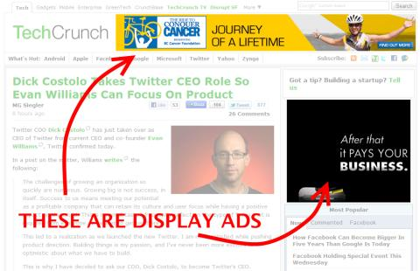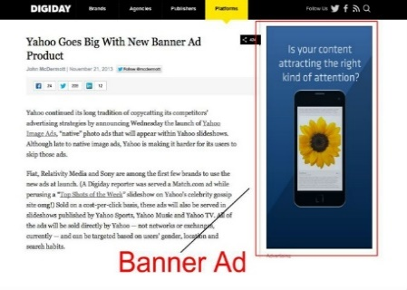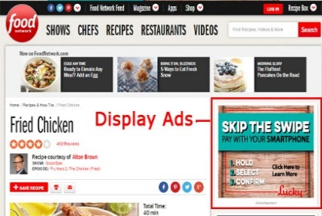

## Section 1.2 Display Advertising Value Chain

**Ad Impressions**

**Ad Inventory**

Demand Side

Supply Side

**Basic terms in display advertising:-**

**Ad Impression -** An ad impression is the delivery of a single ad to a single individual. Counting impressions is the method by which Web advertisement is accounted and paid for.

**Ad Inventory** – A collection of ad impression is known as ad inventory. It is actually the number of advertisements, or amount of ad space, a publisher has available to sell to an advertiser. Online ad inventory is often valued in terms of the site traffic or ad views that the publisher can deliver to the advertiser.

**Volume -** The total number of impressions that a publisher can offer to the advertisers. Volume is always greater than or equal to the number of impressions

**House Impressions** - The number of times the in-house content was displayed. For ex: Windows 10 launch ads displayed on MSN.com

**Fill Rate -** (Impressions/volume)*100. The metric to calculate the amount of inventory that is filled by impressions. Fill rate considers both paid and house impressions.

**Sell Through Rate** - (Paid Impressions/Volume)*100. Percentage of ad inventory sold. This excludes the house impressions

**Click Through Rate:** It is a ratio of clicks to impressions. Used to measure the success of the advertising effort of the advertiser.

**Pricing Options -**

**CPC** – CPC stands for **Cost per click**. It is an internet advertising model where the advertiser pays the publisher when the ad is clicked. Clicks are a way to measure attention and interest. There are two primary models for determining pay-per-click: flat-rate and bid-based. In both cases, the advertiser must consider the potential value of a click from a given source. This value is based on the type of individual the advertiser is expecting to receive as a visitor to his or her website, and what the advertiser can gain from that visit, usually revenue, both in the short term as well as in the long term.

**CPI** – CPI stands for **Cost per Impression**. It refers to the cost of internet marketing where advertisers pay each time an ad is displayed. The risk associated with selling the inventory is minimal as the advertiser pays for only showing the ad and response of the customer is not taken in to account.

**CPM –** CPM stands for Cost per Mille or Cost per Thousand. Publishers mostly sell their inventory in Cost per thousand impressions.

**CPA –** CPA stands for Cost per acquisition/action. In this case, the advertiser only pays when a particular action (defined by the advertiser) is performed by the user through the ad.

## 1.2.1 Ad Exchange

**The problem with Ad Networks:** The key challenge with being an ad network is that you have to grow the supply side of your business (the publishers) in parallel with the demand side (the advertisers) – there’s no point signing up a huge batch of new publishers if you’ve no one to sell their inventory to.

To solve this problem, the ad networks have brokered relationships with one another over the years so that, if a network has an impression that it needs to sell, but doesn’t have an advertiser to sell it to, it can sell that impression to another network. Similarly, in the reverse case, if a network has an opportunity to sell an ad, but doesn’t have the inventory to fulfill the sale, it can buy the inventory from another network.

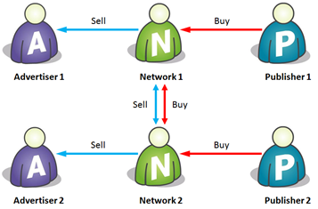

Fig. Relationship between networks

If there were just two or three ad networks in the world, this might not be a problem. But of course there aren’t – there are three hundred. But each ad network can’t have a relationship with every other ad network; each network would have to maintain 299 relationships, which comes to (299 + 298 + … + 2 + 1) = 44,850 relationships!!

**The Solution – Ad Exchange:**

Rather than the ad networks all dealing with each other directly, we need some kind of impartial intermediary which can act as a central hub through which the networks can trade. Such a central hub is an Ad Exchange. By adding an ad exchange into the picture, the trading relationships look as follows

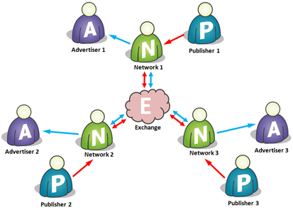

Fig. Trading relationship with an Ad Exchange

Now each ad network has just one trading relationship – with the exchange. So if there are 300 networks, there are 300 relationships, and every network is just one ‘hop’ away from every other network.

What this is means is that for a given ad impression on a publisher site, the network that owns that impression can say to the exchange, “what am I bid on this impression (one careful owner, full service history, nice neighborhood, good references)?”. The exchange can then hawk that impression to all the other networks and solicit bids. Depending on the data that is attached to the impression (or a cookie that one or more of the other networks may recognize and be able to attach data to), the various networks may be able to sell that impression for a greater or lesser amount. So the bids come in, the winning bid is selected, and passed back to the originating network; and if that bid is better than what the network could get from its own advertisers, it wins, and the ad is served.

**Advantages:**

* Crucially, there are only ever two networks (plus the exchange) in this transaction. So each network will take a cut of the impression price, and the exchange will charge a flat transaction fee (this is essential to maintain the exchange’s impartiality – taking a cut would introduce bias). Just having two networks in the transaction means more money for the networks and the publisher, and possibly better pricing for the advertiser. So everyone wins!!
* One of the irritating things about running an ad network is having to match demand to supply – as networks grow, they have to recruit both advertisers and publishers. The network model allows one-sided participants to flourish, dramatically increasing the range of ways in which businesses can participate in this market

In the below example, Network 2 doesn’t actually source any inventory direct from publishers – it gets it all from the network, and focuses on being great at selling that inventory to advertisers. Another (perhaps better) name for the kind of company that does this is a Media Agency

Example: Havas, Amazon, eBay

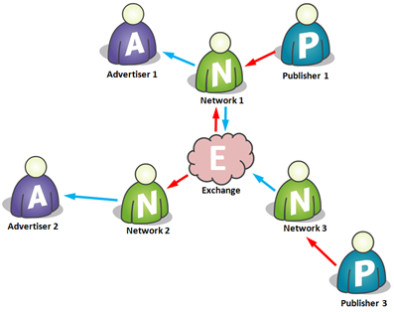

Fig. Media Agency and Sales House

Similarly, Network 3 above has decided to do away with its advertiser customer base and just sell all its inventory to the exchange. In this sense it becomes a bit more like an ad sales house or publisher aggregator than a true network.

Example: Six Apart

## Section 1.3 Ad Serving Process

Back in olden days, the ad serving process used to take place as follows –



**User**

**Publisher**

**Web Server**

Drawbacks of this approach –

* + Every time the Ad changes, the whole live website was to be changed
  + The process was time consuming and tedious

Post this, publisher ad servers were introduced where whenever the user would request the publisher for an advertisement, for which the publishers directed him to a completely separate server called publisher`s ad server, which acts as a repository of advertisements.

[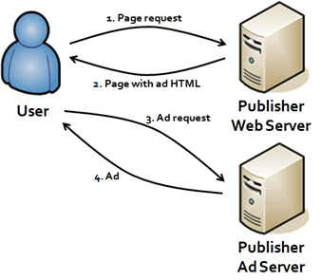](http://www.google.co.in/url?sa=i&rct=j&q=&esrc=s&frm=1&source=images&cd=&cad=rja&uact=8&docid=_cozIOfuPm0WaM&tbnid=JBgEJcnRj-VnCM:&ved=0CAUQjRw&url=http://www.liesdamnedlies.com/2008/06/online-advert-1.html&ei=7L7IU62oA8KJuATW7ID4BA&bvm=bv.71198958,d.c2E&psig=AFQjCNEP6BIarIGXKTisgfYBhud2c6aMMA&ust=1405751382847761)

So, the need to ask advertisers for an advertisement, to get it displayed each time, was eliminated. However, the advertisers were faced with some of the problems like:-

* They were not able to track their performance across multiple publishers
* Not able to decide pricing as they had no information about how many times an ad is served
* They could not vary the delivery rules of a campaign

To eliminate the above problems and provide more autonomy over advertising to advertisers, came the concept of advertiser’s ad servers.

It basically provides an advertiser with many functions like:-

1. Design a campaign for an ad and implement rules like frequency capping, ad rotation etc.
2. Tracking delivery of an ad across all sites.
3. Measuring the impact of an ad (number of clicks, conversions etc.)
4. Making any changes in the advertisements.

So, now the user request for an ad to publisher, who directs the user to publisher ad server, which redirects the user to advertiser`s ad server.

[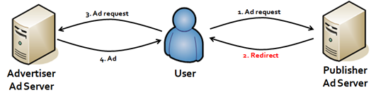](http://www.google.co.in/url?sa=i&rct=j&q=&esrc=s&frm=1&source=images&cd=&cad=rja&uact=8&docid=_cozIOfuPm0WaM&tbnid=pi8ih0ZBZMmnIM:&ved=0CAUQjRw&url=http://www.liesdamnedlies.com/2008/06/online-advert-1.html&ei=kMPIU5XfHMqwuAT_-YGQCQ&bvm=bv.71198958,d.c2E&psig=AFQjCNEP6BIarIGXKTisgfYBhud2c6aMMA&ust=1405751382847761)

Currently Microsoft/Atlas (with media console) and google/double click (with DFA) are the major players in advertiser’s ad server market.

Now a days, advertiser ad serves tend not to actually serve the ad, and have outsourced this task to CDN (Content Delivery Network) which maintain thousands of servers across Internet to serve ads on behalf of other people. This is done to simplify the process and maintain one to many relationships across web.

[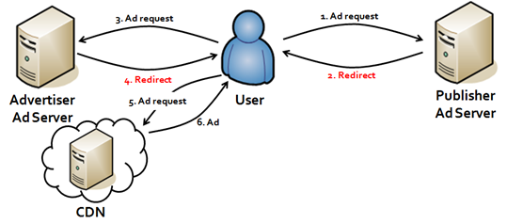](http://www.google.co.in/url?sa=i&rct=j&q=&esrc=s&frm=1&source=images&cd=&cad=rja&uact=8&docid=_cozIOfuPm0WaM&tbnid=7R-FrD3sfdApjM:&ved=0CAUQjRw&url=http://www.liesdamnedlies.com/2008/06/online-advert-1.html&ei=QsjIU8SeNZePuASW1IHICQ&bvm=bv.71198958,d.c2E&psig=AFQjCNFnk9K4ECL97dtX4HT1OdZW0r-kkA&ust=1405753790708415)

## Section 1.4 Targeting in Display Advertising

## 1.4.1 Run of Classification

#### Booking level

*Granularity increases*

*Price increases*

1. Run of terminal location

Exact location on a page as to where the ad must appear

1. Run of site

The specific websites on which the ad must appear

1. Run of channels

Sports/music/entertainment etc.

1. Run of network

The network of publishers on which the ad may appear

Similarly, advertisers can opt out of specific placements, sites, etc.:

#### Opt out levels

1. Placement
2. Site
3. Publisher
4. Exchange/network
5. IAB category

## 1.4.2 User Targeting

**Targeted advertising** is a type of advertising whereby advertisements are placed so as to reach consumers based on various traits such as demographics, psychographics, behavioral variables (such as product purchase history), and firmographics.

**Advantages** –

* Ads shown using targeting will be more pertinent and useful for the customers
* A study in 2009 showed that targeted adverting secured an average of 2.7 times as much revenue per ad as non-targeted "run of network" advertising
* It is twice as effective at converting users who click on the ads into buyers
* Also the cost per conversion reduces for the advertisers

#### 1.4.2.1 Types of Users

#### 1.4.2.1 Targeting Criteria

There are two basic targeting criteria’s used by the advertisers –

## Section 1.5 Display Lumascape

The document is attached - 

### Section 2

MSFT Display Advertising

## Section 2.1 MSFT Properties

There are 6 different publishers in MSFT display ads –

* MSN
* Outlook
* Skype
* WinStore
* Xbox
* LinkedIn

## Section 2.2 MSFT Inventory Flow

## 2.2.1 Pre Transition Phase

Microsoft display advertising business worked through basically three platforms:

1. Ad Expert
2. MSFT Ad Exchange (through AppNexus)
3. AMAN

If some ad inventory is not sold by the due time, Microsoft show their house ads or make good ads

##### 2.2.1.1 Ad Expert

Ad Expert was Microsoft’s premium ad network that served advertisers with high quality inventory and guaranteed delivery through preordering. This is the platform through which MSFT sold its premium ad inventory. The order item consists of the following advertiser requirements:

* Impressions goal

The target impressions to be delivered by MSFT

* Start & end date

The tenure of the campaign for which the impressions need to be served

* Booking level

The level at which the advertiser chooses to place the order, i.e. mentioning the placement/site/exchange where his ad should appear

* Opt out

The advertiser could also choose as to where the ad should not appear

* Frequency capping & similar options

Options as to how many times an ad should appear in a day or the sequence through rotation, etc.

* Target audience

The audience by whom the ad must be viewed

* CPM

The cost per mille at which these impressions are sold (varies with the order)

##### 2.2.1.2 Microsoft Ad Exchange

While the demand is not always met by the inventory there is always surplus inventory that is not consumed by the demand side. This surplus inventory is sold through AppNexus by allowing advertisers to bid for impressions – Real Time Bidding. MSFT provides a platform called MSFT Ad Exchange (MAX) through which RTB can take place. AppNexus is a very large ad exchange which rarely falls short of inventory. Though targeting cannot be achieved to the level provided by AdExpert, targeting can be done to an extent depending on the inventory available through MAX.

##### 2.2.1.3 Ad Market AppNexus (AMAN)

AMAN is an ad network, which acquires ad inventories from AppNexus via 3PA (third party AMAN). Moreover the surplus from MAX is also given to AMAN. AMAN is a platform which does not give guarantee to the advertiser. Advertisers with a small budget and who are willing to take a low quality impression acquire the impression. Advertisers use CPC, CPA and CPM as the standard of pricing to acquire the inventory. The remnant inventory available even after buys from AMAN becomes a place for House ads, i.e. MSFT ads.

The order items of AMAN are

* Budget
* Start date
* End date
* CPM/ CPA/ CPC
* Targeting

##### 2.2.1.4 Shortcomings of Pre Transition Phase

* Revenue generated by Microsoft in display ads decreased over the tenure
* O&O products and third party publishers were not able to pool in the desired traffic
* Hence, Microsoft was not able to sell off its inventory to the advertiser at the profitable price
* With the advancement of display ads, Microsoft had to invest in the technology upgrades and had to maintain inventory
* Microsoft started outsourcing the sales process focusing on more profitable ventures of its own

## 2.2.3 Post Transition Phase

Due to the shortcomings faced during the pre- transition phase, MSFT outsourced the selling of its display ads inventory to 3rd party network/ exchanges i.e. AOL and AppNexus. Post the transition the inventory flow is as follows –

**AOL9 Markets** - Brazil, Canada, France, Germany, Italy, Japan, Spain, United Kingdom, United States

**AN10 Markets** - Austria, Belgium, Denmark, Finland, Ireland, Netherlands, Norway, Portugal, Sweden, Switzerland

## 2.2.3.1 MSFT – AOL Deal

The Deal –

* The ten year deal started from 1st Jan, 2016
* AOL will handle display, mobile and video ad sales for Microsoft properties in the top 9 global markets
* The deal also saw a transition of 1200 people from Microsoft to AOL

Advantage for MSFT –

* Bing will replace Google search engine on AOL sites
* This will provide 100% search results and search ads to Microsoft when people search using AOL sites

## MSFT – AppNexus Deal

AppNexus sells MSFT display ads programmatically for 58 markets worldwide. Some time back, Mexico was tapped for reserved buying and deals

Advantage-

* AppNexus handles the bidding process for the remnant inventory, which has wide number of ad networks hence there by increasing the possibility of selling inventory at higher rates
* Caters the market not supported by AOL there by increasing the traffic

## Section 2.3 AppNexus – RTB Process

**What is Real Time Bidding (RTB) / Real Time Auction?**

* **Real-time bidding** (**RTB**) refers to the means by which ad inventory is bought and sold on a per-impression basis.
* With real-time bidding, advertisers bid on an impression and, if the bid wins, the advertiser’s ad is instantly displayed on the publisher’s site.

**AppNexus RTB** –

* After an inventory is being passed to AppNexus, RTB process is initiated in which the inventory is sold with respect to the bids placed by the advertisers
* Advertisers take part in First Price Auction & Second Price Auction with respect to the floor price they hit
* Advertisers are not aware of the bids pitched in by other advertisers but after the auction process is over they are provided with the list of winning bid
* Generates transparency between AppNexus & advertisers, also help the advertisers to analyze their own bid and the value of the inventory at stake

## 2.3.1 Floor Pricing

**Hard Floor Pricing**: Minimum bid an advertiser needs to clear so as to take part in the auction, pre-defined number by AppNexus  
**Soft Floor Pricing**: Is higher than Hard Floor Pricing, is used to normalize the bidding process

Additional read on different auction mechanisms: - <https://www.livemint.com/Opinion/i0GBWx8AG4V6VwLiMOWPDN/The-auction-that-runs-the-internet.html>